Value at Risk

1

1/23/2021-08:11:621 2011 to 2020

Publications by Subject Area

Entity: 11/23/2021-08:11:621 · Year range: 2011 to 2020 · Data source: Scopus, up to 17 Nov 2021 ·

Scholarly

Field-Weighted Citation

Subject Area

1/23/2021-08:11:621

Output Citations Authors

Impact

1

1,864

849

15,399 3,418

7,686 1,581

0.81

Economics, Econometrics and

Finance

0.86

0.84

Mathematics

626

5,263 1,220

Computer Science

450

428

3,713 973

2,903 917

0.82

0.65

Business, Management and

Accounting

Decision Sciences

Engineering

362

301

91

4,272 748

2,070 740

1,255 251

467 218

249 152

495 143

156 69

105 56

0.97

0.74

1.16

0.71

0.67

1.16

0.59

0.66

Energy

Social Sciences

91

Physics and Astronomy

Environmental Science

Earth and Planetary Sciences

61

45

25

Agricultural and Biological

Sciences

22

Materials Science

12

35 39

0.59

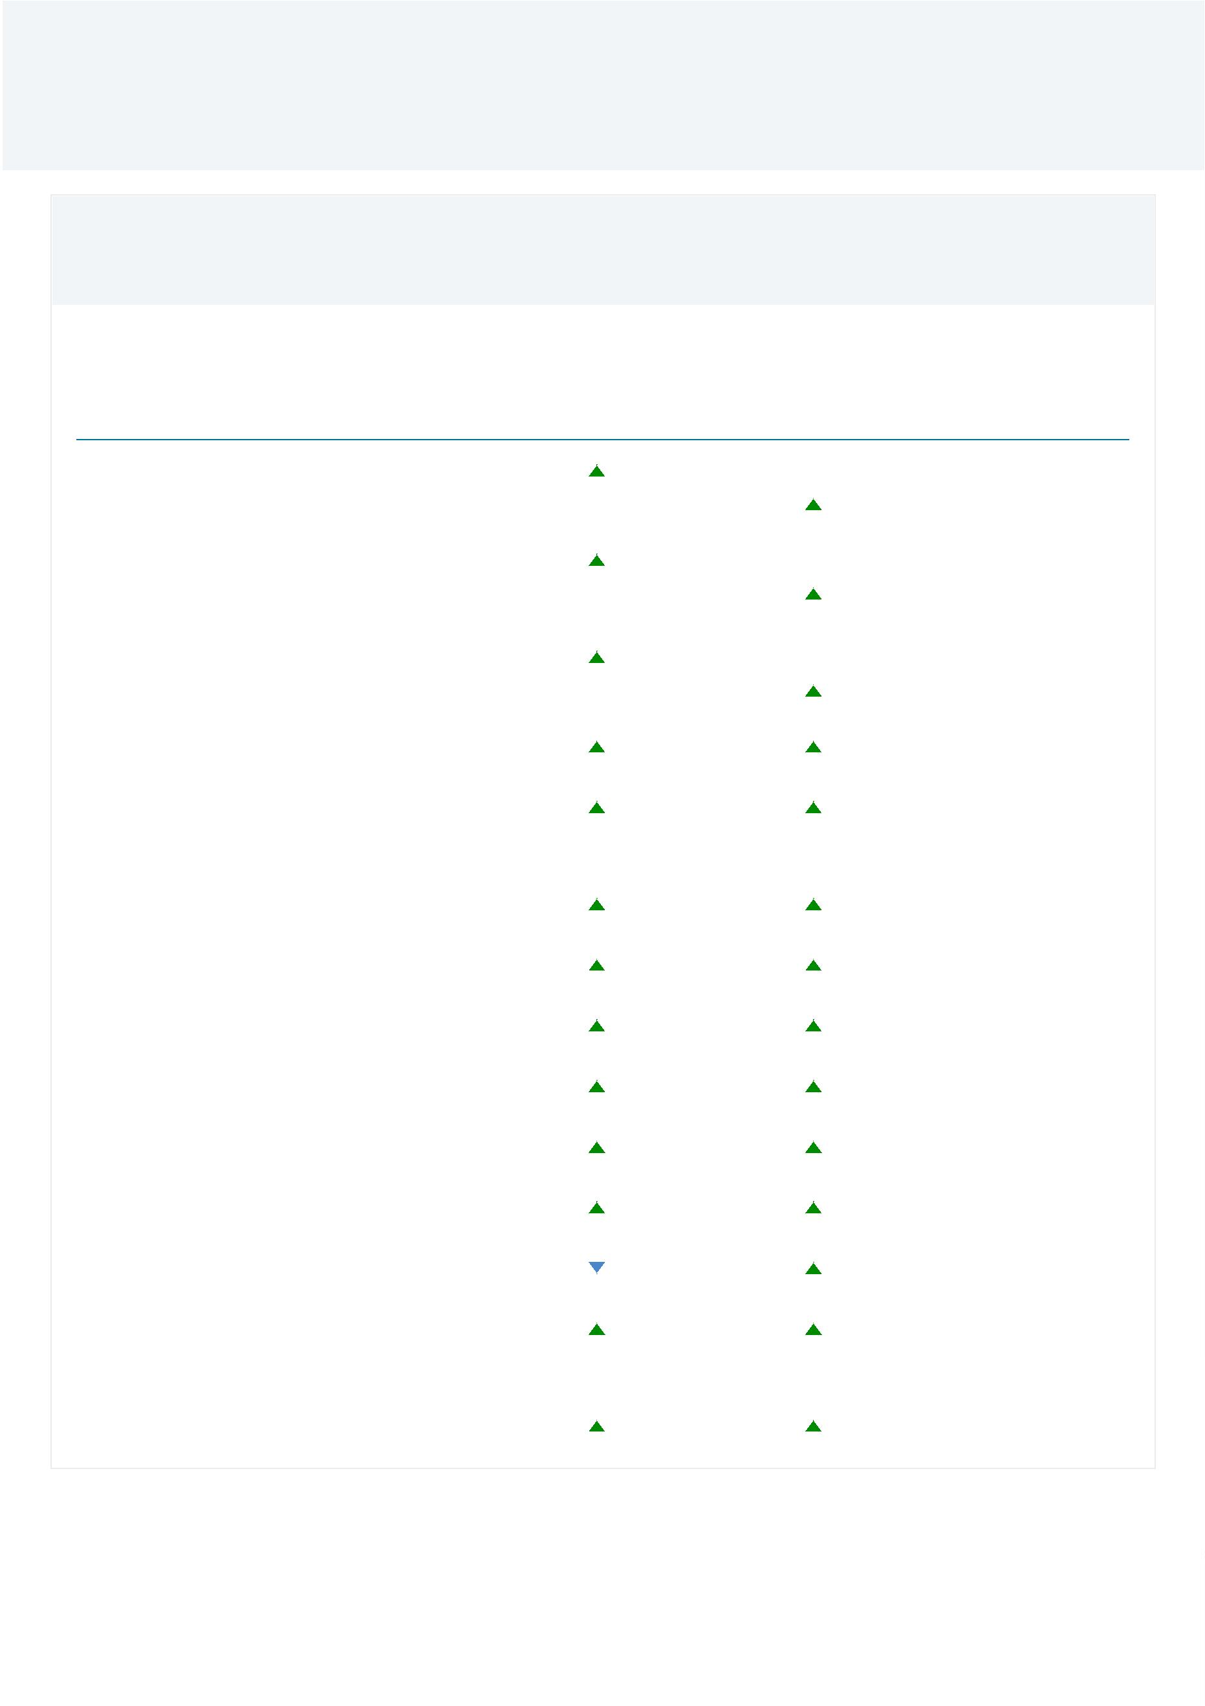

Publications by Subject Area

Scholarly

Output Citations Authors

Field-Weighted

Citation Impact

Subject Area

Arts and Humanities

7

7

36 15

19

0.33

0.19

Biochemistry, Genetics and Molecular

Biology

9

Chemical Engineering

Multidisciplinary

Chemistry

7

6

4

4

3

2

1

1

36 23

12 17

0.91

0.03

0.28

0.98

0.82

0.69

0.50

0.00

4

92

43

10

3

11

9

Medicine

Psychology

7

Neuroscience

8

Immunology and Microbiology

Nursing

4

0

5

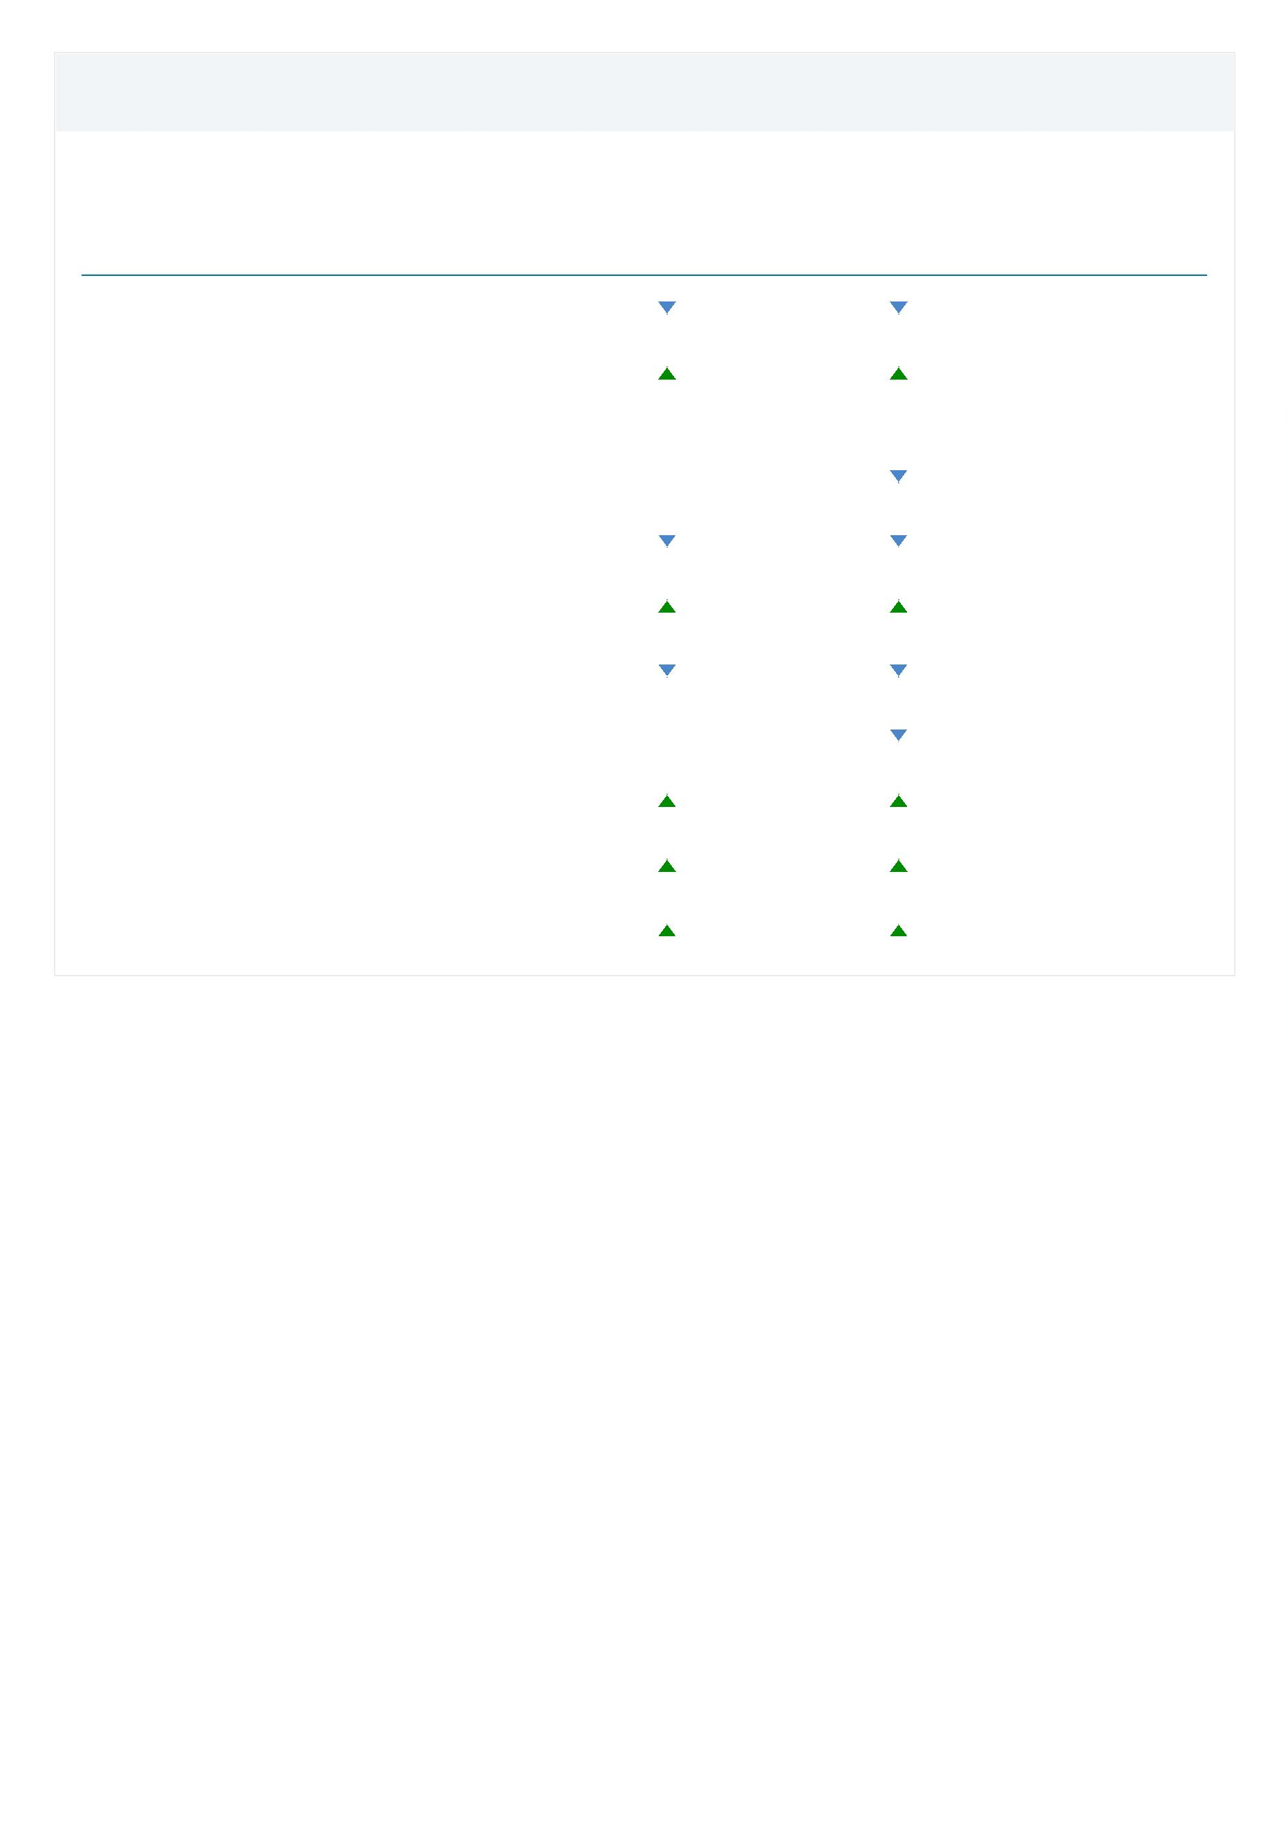

Publications by Journal quartile

Entity: 11/23/2021-08:11:621 · Year range: 2011 to 2020 · Data source: Scopus, up to 17 Nov 2021 ·

Share of publications per Journal quartile by CiteScore Percentile

Publication

share (%)

2

2

1

1

50

00

50

00

Quartiles

Q1 (top

Publications

568

37.7

29.3

20.8

12.2

2

5

7

1

5%)

5

0

0

Q2 (26% -

0%)

441

313

183

Q3 (51% -

5%)

Q4 (76% -

00%

Cumulative

shares

Publication

share (%)

Publications

1,009

Q1 to Q2 (top

67.0

5

0%)

Q1 to Q3 (top

75%)

1,322

87.8

Scholarly Output

Entity: 11/23/2021-08:11:621 · Year range: 2011 to 2020 · Data source: Scopus, up to 17 Nov 2021 ·

1

,864

2

2

1

1

50

00

50

00

number of publications by authors

in 11/23/2021-08:11:621

5

0

0

2

011 2012 2013 2014 2015 2016 2017 2018 2019 2020

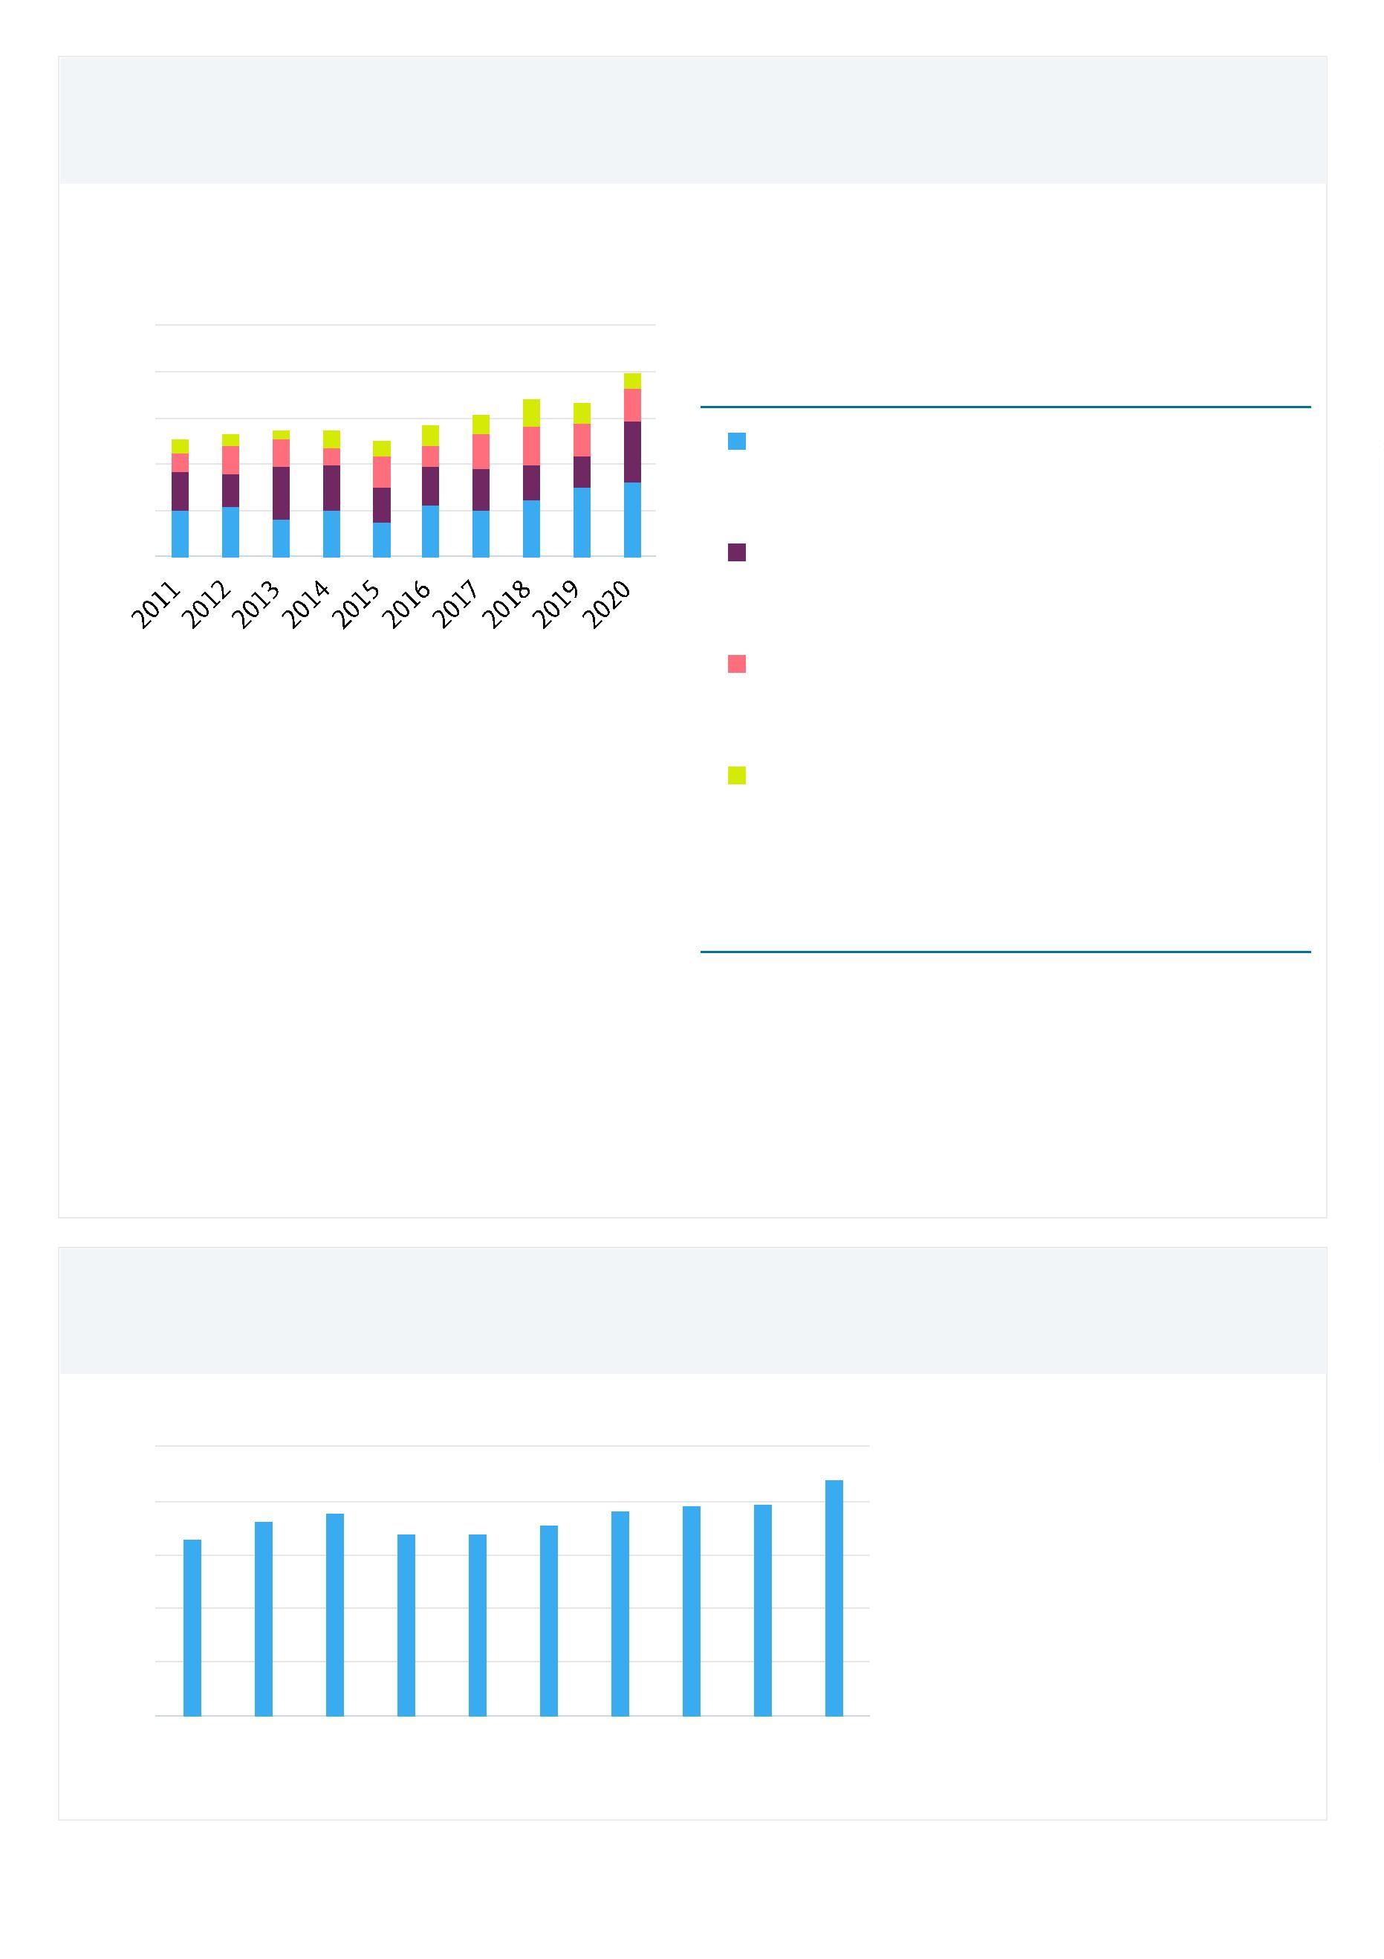

Outputs in Top 10% Citation Percentiles (field-weighted)

Entity: 11/23/2021-08:11:621 · Year range: 2011 to 2020 · Data source: Scopus, up to 17 Nov 2021 ·

Share of publications in 11/23/2021-08:11:621 that are among the most cited publications worldwide

**field-weighted**

1

43 (7.7%)

1

1

2%

0%

number of publications in the top 10%

most cited publications worldwide

8

6

4

2

0

%

%

%

%

%

2

011 2012 2013 2014 2015 2016 2017 2018 2019 2020

%

%

publications in top 10% most cited

publications in top 1% most cited

Publications in Top Journal Percentiles by CiteScore Percentile

Entity: 11/23/2021-08:11:621 · Year range: 2011 to 2020 · Data source: Scopus, up to 17 Nov 2021 ·

Share of publications in 11/23/2021-08:11:621 that are in the top journals by CiteScore Percentile

2

12 (14.1%)

2

1

1

0%

6%

2%

number of publications in the top 10%

journals by CiteScore

8

4

0

%

%

%

2

011 2012 2013 2014 2015 2016 2017 2018 2019 2020

%

%

publications in top 10% journals

publications in top 1% journals

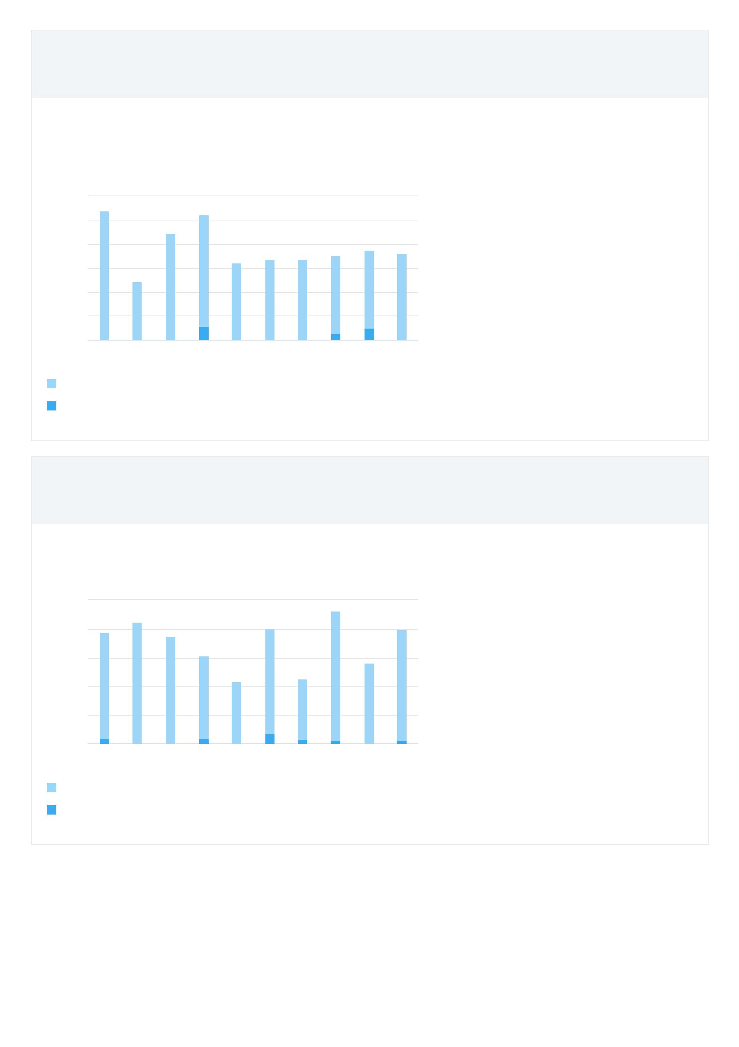

Most cited publications

Entity: 11/23/2021-08:11:621 · Year range: 2011 to 2020 · Data source: Scopus, up to 17 Nov 2021 ·

Publication

Citations

228

Systemic risk measurement: Multivariate GARCH estimation of CoVaR.

Girardi, G., Tolga Ergün, A.

(2013) Journal of Banking and Finance, 37 (8), pp. 3169-3180.

Evaluating value-at-risk models with desk-level data.

Berkowitz, J., Christoffersen, P., Pelletier, D.

(2011) Management Science, 57 (12), pp. 2213-2227.

155

128

Systemic risk in European sovereign debt markets: A CoVaR-copula

approach.

Reboredo, J.C., Ugolini, A.

(2015) Journal of International Money and Finance, 51, pp. 214-244.

Risk neutral and risk averse Stochastic Dual Dynamic Programming method.

Shapiro, A., Tekaya, W., Da Costa, J.P. and 1 more

(2013) European Journal of Operational Research, 224 (2), pp. 375-391.

123

122

Mean-variance approximations to expected utility.

Markowitz, H.

(2014) European Journal of Operational Research, 234 (2), pp. 346-355.



Topics

Entity: 11/23/2021-08:11:621 · Year range: 2011 to 2020 · Data source: Scopus, up to 17 Nov 2021 ·

**At this Publication Set**

**Worldwide**

Field-

Weighted

Scholarly Publication Citation Prominence

Topic

Output

Share Impact percentile

Value at Risk; GARCH Model;

Backtesting ...

T.1263

346 17.58%

0.70 94.505

0.85 91.958

0.63 85.420

Optimal Reinsurance; Risk Measures;

Expected Shortfall ...

T.6369

189 12.43%

Extreme Value Index; Tail Index;

Generalized Pareto Distribution ...

T.4946

84 7.47%

Copula; Tail Dependence; Vines ...

T.3443

79 3.81%

48 3.55%

0.92 94.627

0.82 94.731

Portfolio Selection; Security Returns;

Semivariance ...

T.5557

Realized Volatility; High-Frequency

Data; Market Microstructure Noise ...

T.7730

45 2.78%

36 1.56%

36 8.82%

0.65 96.165

0.51 94.745

0.32 72.887

Credit Default Swaps; Loss Given

Default; Credit Risk ...

T.1322

Operational Risk; Regulatory Capital;

Basel Committee ...

T.21405

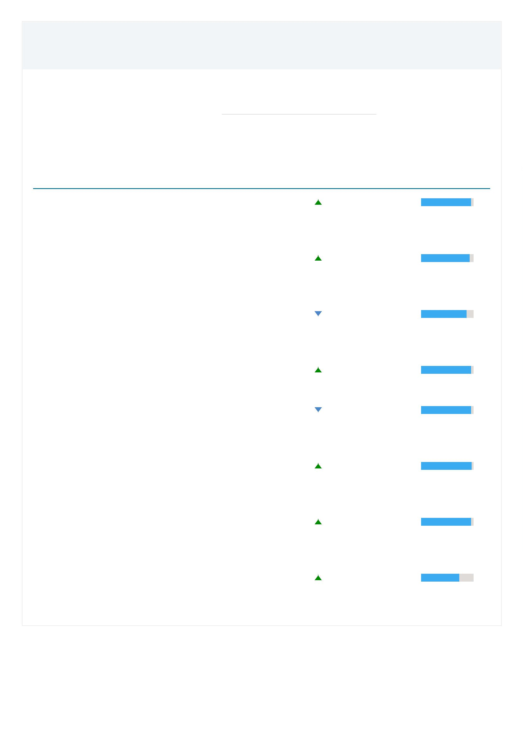

Topics

**At this Publication Set**

**Worldwide**

Field-

Weighted

Scholarly Publication Citation Prominence

Topic

Output

Share

Impact percentile

Risk Aggregation; Dependence

Structure; Value at Risk ...

T.29779

29 12.95%

1.82 60.123

Systemic Risk; Financial Networks;

Interbank Markets ...

T.13598

25 1.36%

1.83 96.772

Collaboration

Entity: 11/23/2021-08:11:621 · Year range: 2011 to 2020 · Data source: Scopus, up to 17 Nov 2021 ·

Scholarly Output in 11/23/2021-08:11:621, by amount of international, national and institutional

collaboration

Field-

Citations Weighted

Scholarly

Output Citations Publication

per

Citation

Impact

Metric

International

28.0%

24.7%

522 6,512

460 3,321

563 3,739

319 1,827

12.5

7.2

6.6

5.7

1.20

0.72

0.67

0.56

collaboration

Only national

collaboration

Only institutional 30.2%

collaboration

Single authorship 17.1%

(no collaboration)

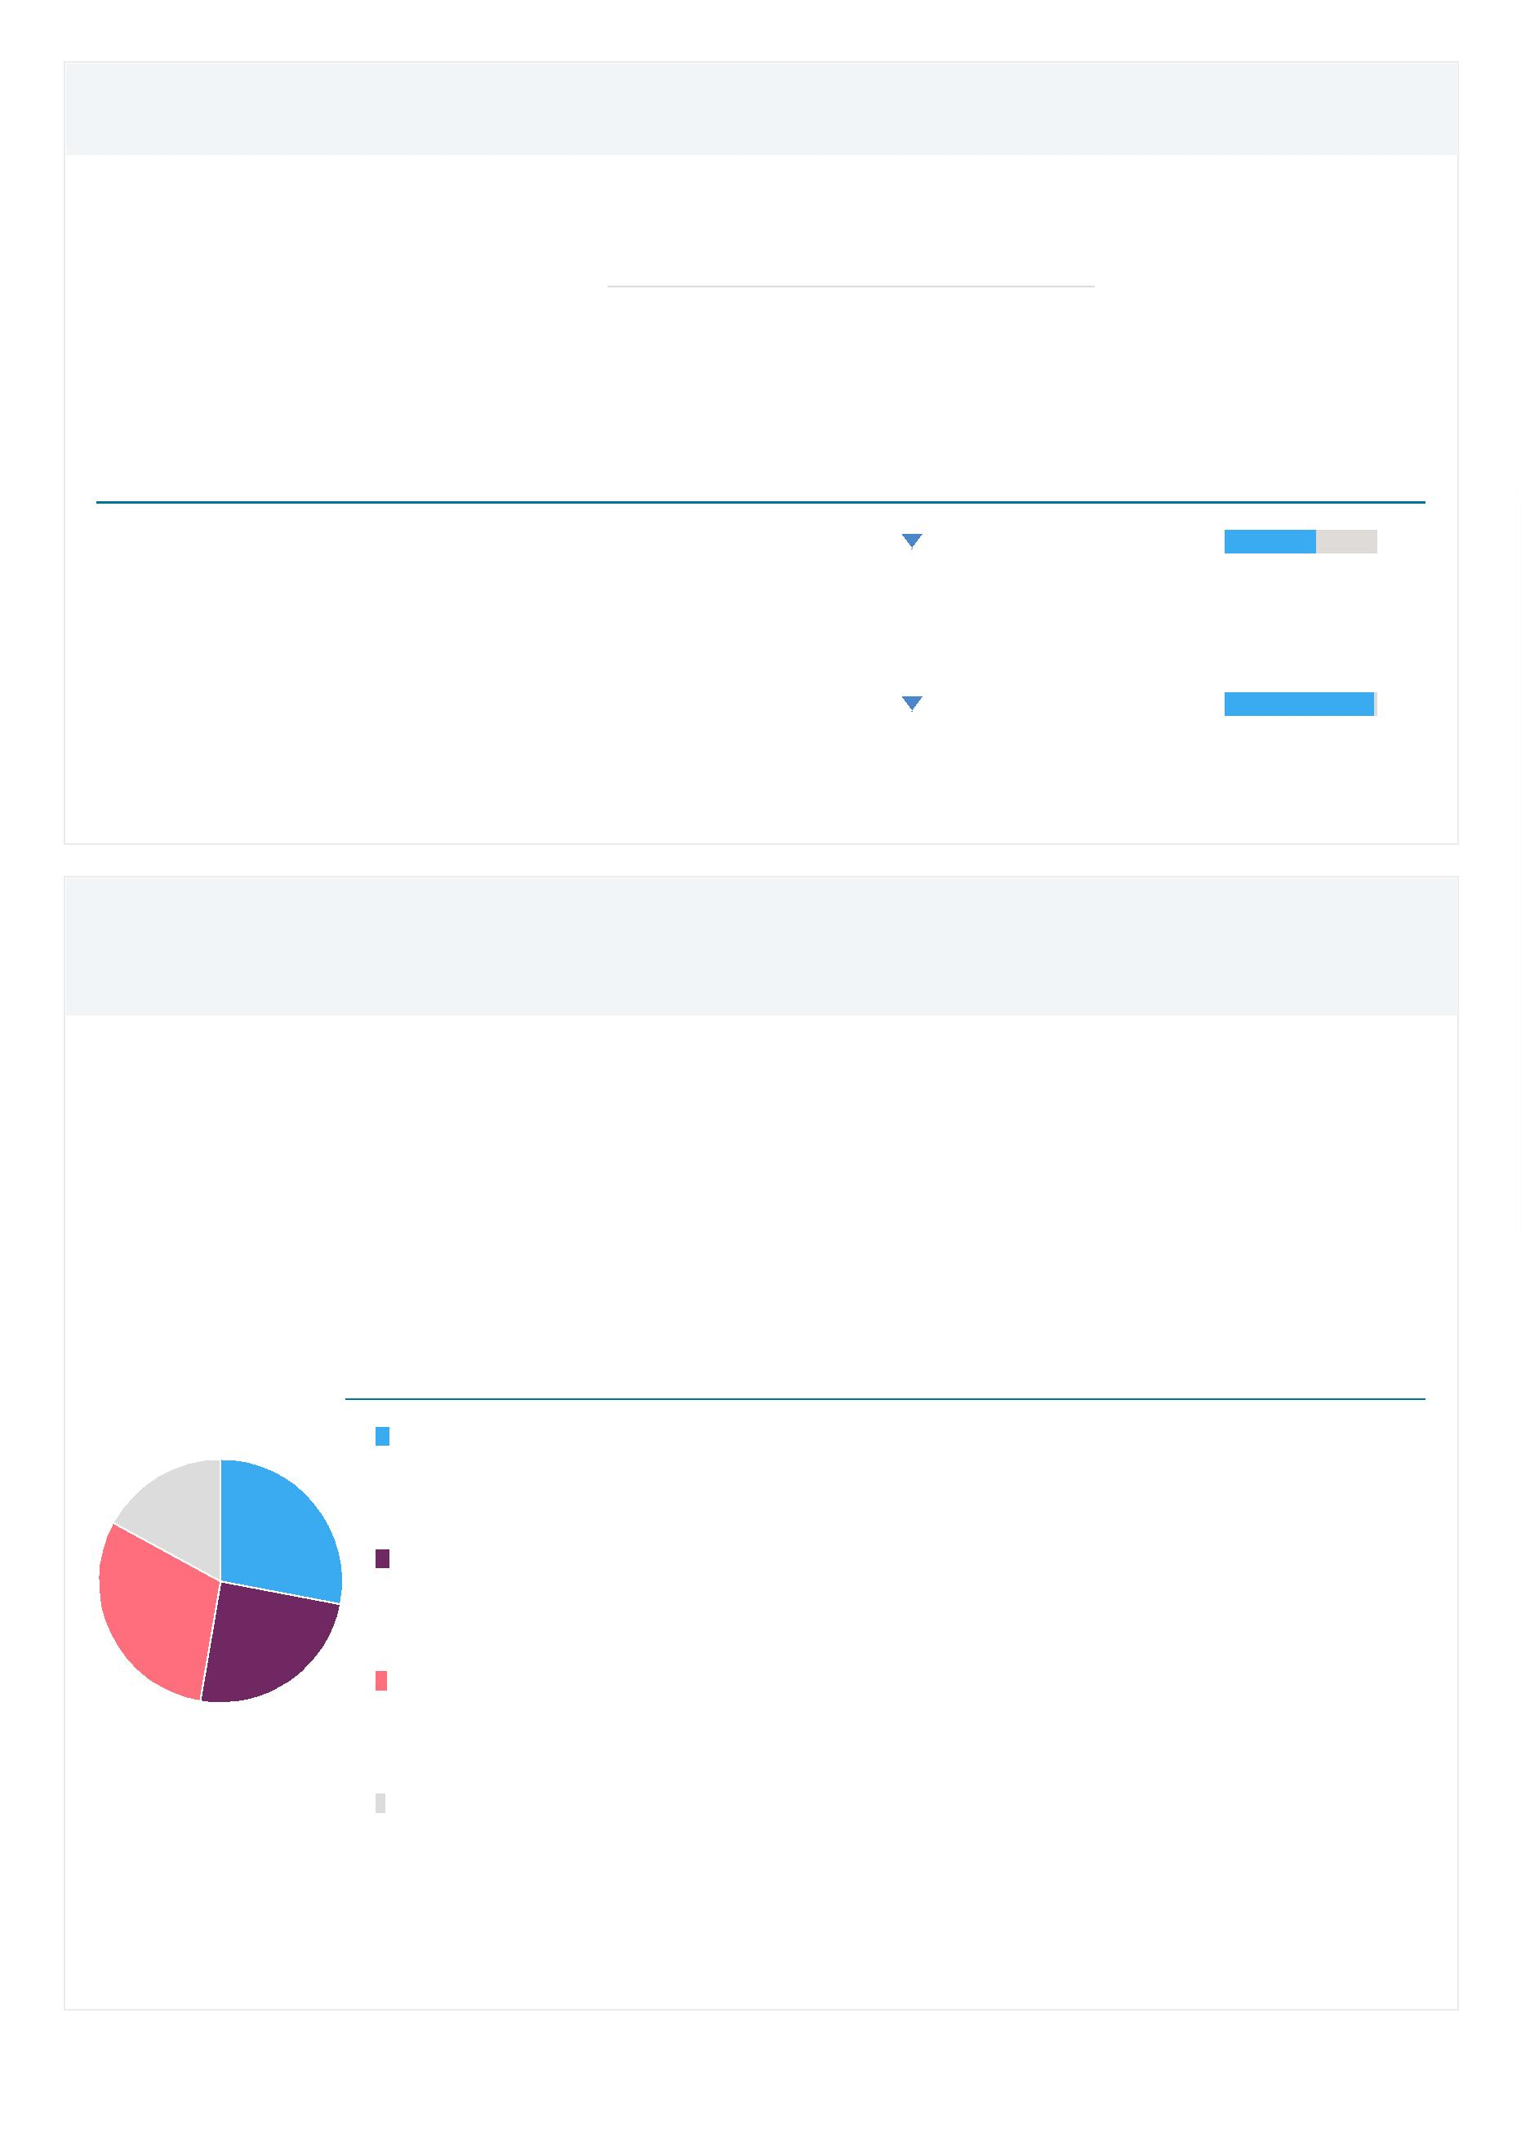

Views Count

Entity: 11/23/2021-08:11:621 · Year range: 2011 to 2020 · Data source: Scopus, up to 17 Nov 2021 ·

4

5,848

6

5

4

3

2

1

,000

,000

,000

,000

,000

,000

0

number of Scopus views received by

publications in 11/23/2021-

0

8:11:621

2

011 2012 2013 2014 2015 2016 2017 2018 2019 2020

Outputs in Top Views Percentiles (field-weighted)

Entity: 11/23/2021-08:11:621 · Year range: 2011 to 2020 · Data source: Scopus, up to 17 Nov 2021 ·

Share of publications in 11/23/2021-08:11:621 that are among the most viewed publications worldwide

**field-weighted**

1

75 (9.4%)

1

1

1

4%

2%

0%

number of publications in the top 10%

most viewed publications worldwide

8

6

4

2

0

%

%

%

%

%

2

011 2012 2013 2014 2015 2016 2017 2018 2019 2020

%

%

publications in top 10% most viewed

publications in top 1% most viewed

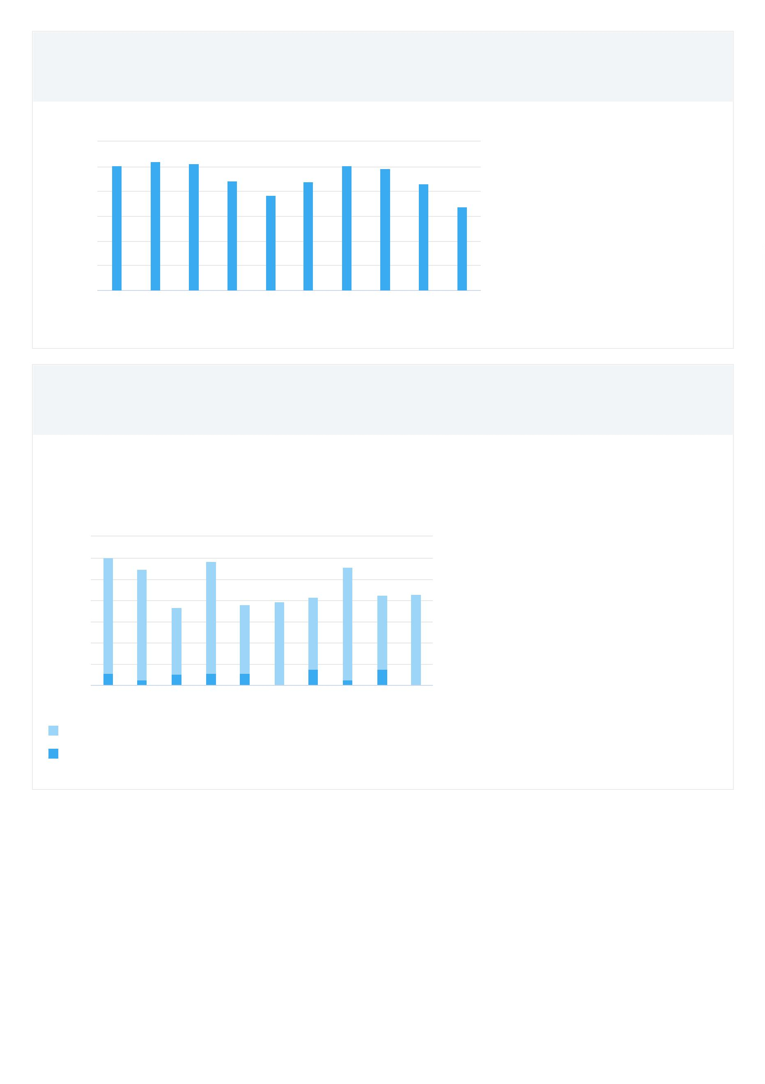

Views per Publication

Entity: 11/23/2021-08:11:621 · Year range: 2011 to 2020 · Data source: Scopus, up to 17 Nov 2021 ·

2

4.6

3

3

2

2

1

1

5.0

0.0

5.0

0.0

5.0

0.0

average number of Scopus views

per publication in 11/23/2021-

08:11:621

5

0

.0

.0

2

011 2012 2013 2014 2015 2016 2017 2018 2019 2020

Field-Weighted Views Impact

Entity: 11/23/2021-08:11:621 · Year range: 2011 to 2020 · Data source: Scopus, up to 17 Nov 2021 ·

1

.04

2

1

0

.0

.0

.0

Field-Weighted Views Impact of

11/23/2021-08:11:621

2

011 2012 2013 2014 2015 2016 2017 2018 2019 2020

Citation Count

Entity: 11/23/2021-08:11:621 · Year range: 2011 to 2020 · Data source: Scopus, up to 17 Nov 2021 ·

1

5,399

2

2

1

1

,500

,000

,500

,000

number of citations received by

publications in 11/23/2021-

0

8:11:621

5

00

0

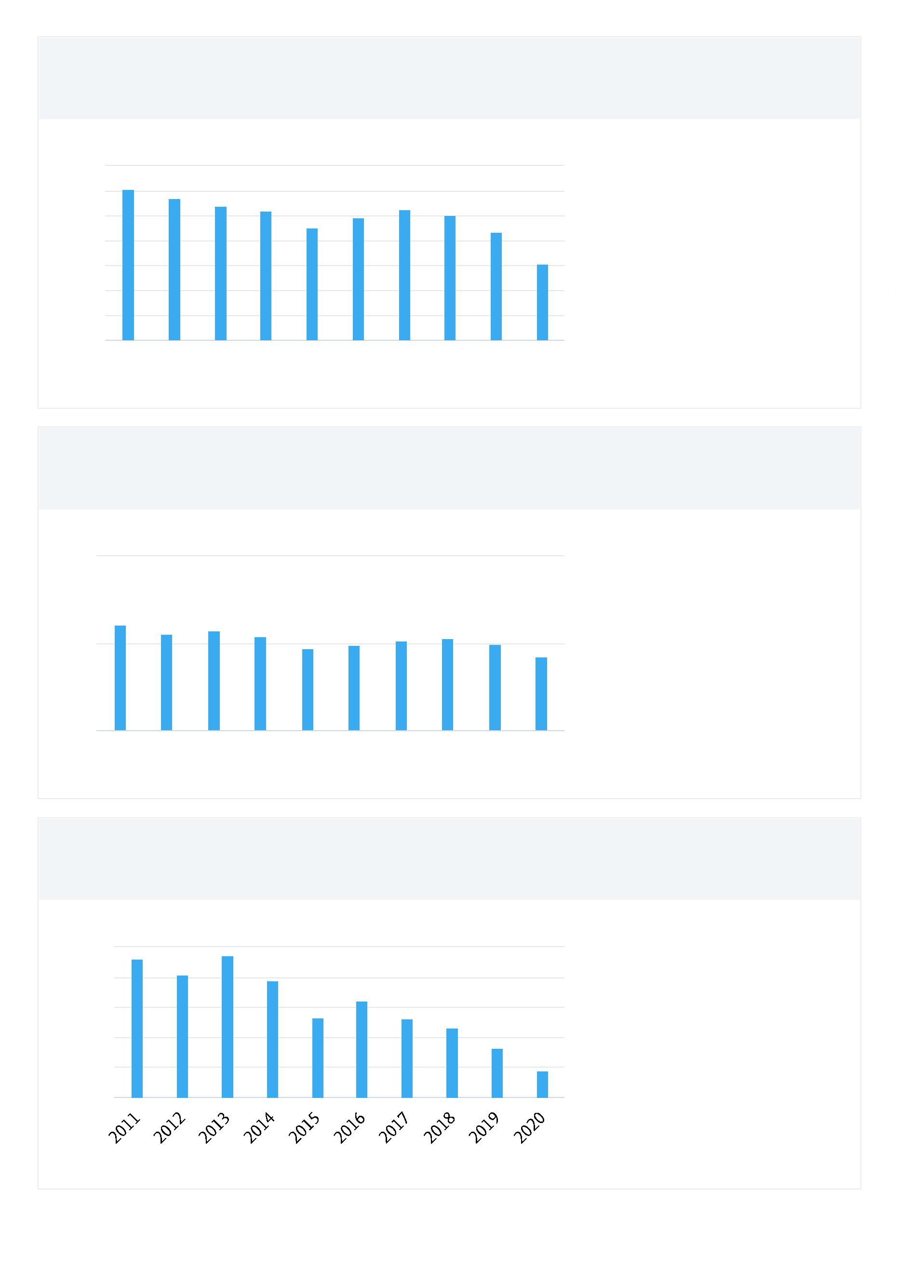

Citations per Publication

Entity: 11/23/2021-08:11:621 · Year range: 2011 to 2020 · Data source: Scopus, up to 17 Nov 2021 ·

8

.3

1

1

1

1

6.0

4.0

2.0

0.0

average number of citations per

publication in 11/23/2021-

8

6

4

2

0

.0

.0

.0

.0

.0

0

8:11:621

Field-Weighted Citation Impact

Entity: 11/23/2021-08:11:621 · Year range: 2011 to 2020 · Data source: Scopus, up to 17 Nov 2021 ·

0

.81

2

1

0

.0

.0

.0

Field-Weighted Citation Impact of

11/23/2021-08:11:621

2

011 2012 2013 2014 2015 2016 2017 2018 2019 2020

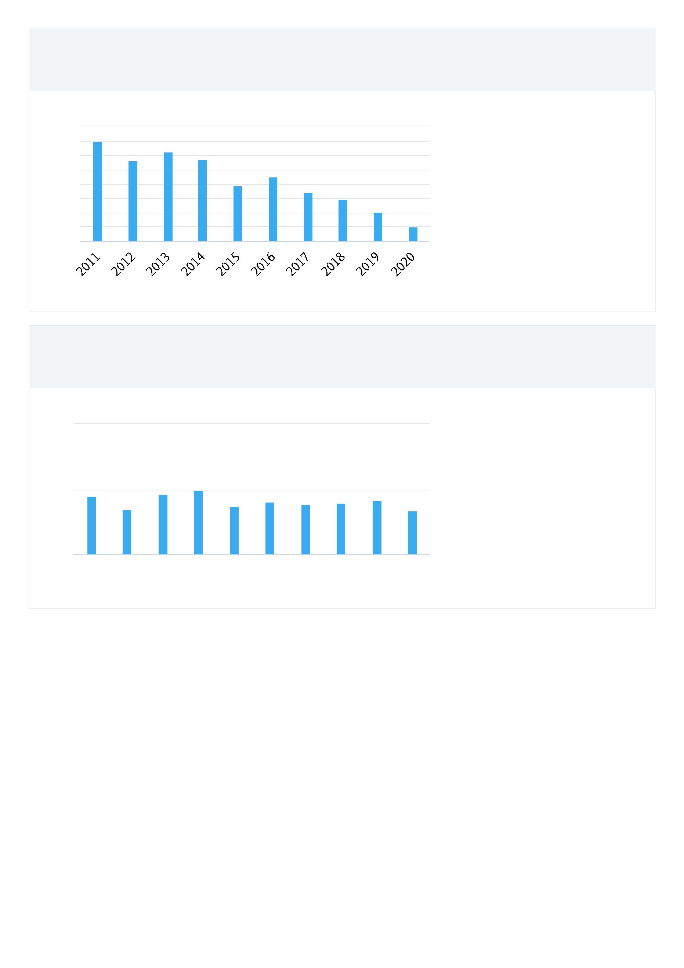

Top Authors

Entity: 11/23/2021-08:11:621 · Year range: 2011 to 2020 · Data source: Scopus, up to 17 Nov 2021 ·

Most recent

Name

Scholarly Output

publication Citations h-index

1

2

3

4

5

6

7

8

9

. Sriboonchiita, Songsak

14

14

14

14

13

12

11

11

9

2020

2020

2018

2016

2019

2020

2020

2020

2020

2020

43

378

222

278

157

195

40

19

14

11

23

44

20

12

19

15

13

. Wang, Ruodu

. Wang, Bo

. Watada, Juilzo

. McAleer, Michael

. Gerlach, Richard H.

. Sukono, undefined

. He, Kaijian

125

64

. Cheung, Kachun

1

0. Yoshida, Yuji

9

22



Institutions

Entity: 11/23/2021-08:11:621 · Year range: 2011 to 2020 · Data source: Scopus, up to 17 Nov 2021 ·

Name

Scholarly Output Authors Citations per Publication

1

2

3

4

5

6

7

8

9

1

.

.

.

.

.

.

.

.

.

University of Waterloo

City, University of London

Erasmus University Rotterdam

University of Barcelona

Complutense University

University of Sydney

35

28

21

20

19

18

18

17

17

16

22

23

15

21

10

8

20.4

17.1

11.0

5.4

6.0

12.9

2.6

Chiang Mai University

Waseda University

22

8

18.2

13.9

8.9

Humboldt University of Berlin

18

12

0. Chinese University of Hong Kong

Citing-Patents Count

Entity: 11/23/2021-08:11:621 · Year range: 2011 to 2020 · Data source: Patent data, up to 17 Nov 2021 ·

Patent office: All Patent Offices

4

3

2

count of patents citing the Scholarly

Output published in 11/23/2021-

1

0

0

8:11:621

2

011 2012 2013 2014 2015 2016 2017 2018 2019 2020

Publication year of Scholarly Output

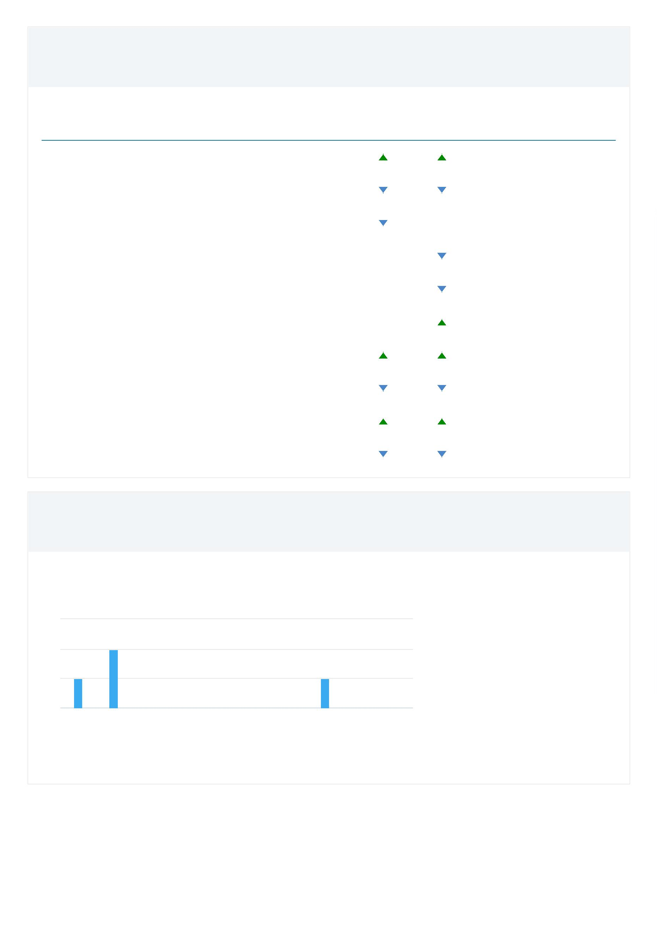

Patent-Cited Scholarly Output

Entity: 11/23/2021-08:11:621 · Year range: 2011 to 2020 · Data source: Patent data, up to 17 Nov 2021 ·

Patent office: All Patent Offices

4

3

2

count of Scholarly Outputs in

11/23/2021-08:11:621 that have

been cited in patents

1

0

2

011 2012 2013 2014 2015 2016 2017 2018 2019 2020

Publication year of Scholarly Output

Patent-Citations Count

Entity: 11/23/2021-08:11:621 · Year range: 2011 to 2020 · Data source: Patent data, up to 17 Nov 2021 ·

Patent office: All Patent Offices

4

3

2

1

0

count of Patent-Citations received

in 11/23/2021-08:11:621

2

011 2012 2013 2014 2015 2016 2017 2018 2019 2020

Publication year of Scholarly Output

